Minutes of the Meeting of Cyngor Cymuned Carno Community Council held on
21st April 2026
At 7.30pm in the Cledan Room, Carno Community Centre

- Present.
 | Cllrs: | J.P. Ellison, M.H. Jones. S.R. Kiely (Vice-Chairperson), W. Le Maitre & T.H. Thomas.
 | Cllr. | Les George, Ward Councillor, Powys CC.
 |  | Alan Humphreys. (Clerk to the Council & RFO).

- Apologies for Absence.
 | Cllrs: | J.C. Barnes (Chairperson) & D.I. Jones.

- Declaration of Interest.
  - None.

- Approval of the Minutes of the Previous Meeting.
  - In the absence of the Chairperson, S.R. Kiely (Vice-Chairperson) chaired the Meeting.
  - The Minutes of 17th March 2026 were unanimously approved.
Proposed: | Cllr. M. Jones. | Seconded: | Cllr. T.H. Thomas.
- Cemetery.
  - Ashley Family Foundation Grant.
    - The initial grant had been declined due to the Foundation re-specifying the categories they would support. However, the Chairperson was able to make a £1,500 grant from her personal allowance.
  - Church Repairs.
    - The Clerk had been advised that these would start in May 2026.

- Matters Arising.
  - Highway Issues.
    - Issues Reported to Powys CC.
Location. | Issue. | Powys Ref. | Comments.
Trem y Noddfa  Carpark | Potholes. | JD171795 | Powys CC Housing are responsible.  16.08.2022. Cllr Les George reported he had chased the matter again.  20.06.2023. Scheduled with Powys CC Housing Budget. Cllr George chasing.  16.01.2024. Update received. Powys Housing talking to Contractors.  01.03.2024. Work scheduled for April 2024.  28.05.2024. Waiting on Contractor.  01.09.2024. Powys waiting Contractor schedule.  13.01.2025. Powys unable to find a contractor.
Trem y Noddfa  Carpark | Blocked Drain. | JD188470
Frankwell.  SY17 5LP. | Overgrown. Flooding issue | 6178-0656-5808-6548. | 25.10.2022. Under investigation  28.10.2022. Passed to Powys CC Land Drainage Section.  18.07.2023. Unable to establish ownership of trees.
Cerniog Bridge  SY17 5LS | Lack of road markings | 0088-0514-9178-8732 | 26.07.2024. Reported  02.08.2024. Added to Works list
Lane to Waun. SY17 5LS | Overgrown verges | 4373-0952-5186-5035 | 26.07.2024. Reported.  02.08.2034. Already reported
1-4 Maes y Dafarn. SY17 5NG. | Over hanging tress blocking footpath, | 5552-4364- 4645- 0228 | 01.02.2025. Reported.
Layby A470 Sarn Bridge | Litter | 3897-2631-5025-0071 | 01.07.2025. As advised by TRA referred to PCC.  04.07.2025 Bring investigated.  12.07.2025. Referred to Street Cleaning.  17,07,2025 Still active.  22.07.2025. Passed to Strat Cleaning.  25.09.2025. Chased
Carno | Replenish Grit Bins. | 1207-9375-0175-6199: | 16.07.2025. Reported  17.07.2025. Being Investigated.  25.092025. Being investigated.  30.09.2025. Scheduled for October 2025  18.11.2025. Chasing why bins not replenished.  25.11.2025. PCC investigating.
Carno | Sweep Lanes | 5747-0437-2000-1993 | 18.11.2025 Reported.  25.11.2025. Job booked.
Tanyllyn Cottages | Clear drains. | 0638-3806-8834-9148 | 25.09.2025. Reported.  24.10.2025. Forwarded to Highways.
Bardy | Bridge damage. | 3852-0035-3895-0119 | 25.09.2025. Reported.  30.09.2025. Advised the bridge is privately owned. Referred to Cllr. George
Tanydew/Stone Hse. | Flooding | 0757-5134-7824-6114 | 25.09.2025. Reported.
Peniel Chapel | Litter bin | 7491-8659-2323-3704 | 25.09.2025. Reported.
Rhyd Bank | Traction Issues | 2491-9428-4881-4816 | 17.12.2025 Reported
Ffinnant/TanyDerw | Collapsed fence | 5521-0612-3812-2261 | 07.04.206. Reported  17.04.2026. Defected detected. Work to be done when resources available.
    - Issues reported to the Trunk Road Authority.
Location. | Issue. | TRA Ref. | Comments.
Ty Mawr Farmyard | No drop kerbs | W24126165. | 02.09.2024. Reported,  22.11.20204 To be actioned 2025 Financial Year.  01.07.2025. TRA sat when PPCC resources available.
Glanhanog turning | Road markings/signs |  | 19.04.2025. Reported  28.04.2025. Referred to WG TRA.  01.07.2025. Junction to be remarked.
A470 Carno | Trees obscuring lights. |  | 01.11.2025. Problem identified. Work to commence
A470 Manhole | Cover broken. Bronfelin |  | 20.01.2026. Reported
A470 Layby | Broken fencing |  | 20.01.2026 Reported.

  - Powys County Councillor Report. (PCC Cllr. Les George).
    - Other than comments on Bardy Bridge, Cllr George had no new information for the Council.
  - Carno Station. (Cllr. J.C. Barne & J.P. Ellison).
    - Cllr J.P. Ellison informed the meeting that all the perspective candidates in the forthcoming Senedd Elections had been written seeking their support for the station re-opening. a meeting in Llanbrynmair to reopen a station had received limited response.
  - Pedestrian Crossings.
    - No news.

  - Website.
    - Cllr. Ellison was arranging a meeting with Gwe Cambrian Web at their offices in Aberystwyth which he, Cllr. Le Maitre and the Clerk would attend.
  - Pontdolgoch Railway Bridge.
    - The Clerk was instructed to write again to the Minister about raising the bridge as the recent works undertaken by Network Rail were deemed in adequate. This may have to wait until after the Senedd Elections.
  - Bardy Bridge.
    - As it had proved impossible to gain any information from Powys CC, Cllr Ellison proposed that a Freedom of Information request be made. This was unanimously agreed.

- Planning Applications.
For further details access the Powys CC Planning Portal
  - Planning Applications.
Application No. |  |  | Location | Description
 |  |  | None.
  - Planning Approvals.
Application No. |  |  | Location | Description
 |  |  | None.
  - Planning Refusals.
Application No. |  |  | Location | Description
 |  |  | None.
  - Planning Applications waiting a Powys CC. Decision.
Application No. |  |  | Location. |  | Description | Response.
1611 | FUL | Land Adj Plassau. |  | Free range poultry unit. |  | No Objection.
1207 | FUL | Glanhanog Isaf Barns |  | Change of use for site to holiday let. |  | Objection.

  - Illegal Dwelling, Glanhanog & Opposite.
    - Still no news.
  - Planning Decision Lists.
19th Jan to 13th March 2026 | None in Carno

- Correspondence.
  - Abbreviations.
CAB. | Citizens Advice Bureau.
CEIC. | Circular Economy Innovation Communities
CMI. | Cambrian Mountains Initiative.
CSAG. | Carno Station Action Group.
DP Police Commissioner. | Dyfed/Powys Police Commissioner.
DPNW. | Dyfed-Powys Neighbourhood Watch
EASC. | Emergency Ambulance Service Committee.
IRP Wales. | Independent Remuneration Panel for Wales.
MWWFRS. | Mid & West Wales Fire & Rescue Service.
NMWTRA. | North & Mid Wales Trunk Road Authority.
NRW. | National Resources Wales.
OLPW. | Older Peoples’ Commissioner Wales.
ONS. | Office for National Statistics.
OP Commissioner. | Older Peoples Commissioner.
OVW. | One Voice Wales.
PAVO. | Powys Association of Voluntary Groups.
PACE. | Powys Action on Climate Emergency.
PAW. | Planning Aid Wales.
PCC. | Powys County Council.
Powys CHC. | Powys Community Health Council.
Powys PSB. | Powys Public Service Board.
Powys RPB. | Powys Regional Partnership Board.
Powys THB. | Powys Teaching Health Board.
PSO Wales. | Public Service Ombudsman for Wales.
RNID. | Royal National Institute for the Deaf.
SPEN. | Scottish Power Energy Networks.
TfW. | Transport for Wales.
WG | Welsh Government.
Welsh TRA. | Welsh Government Trunk Road Authority.
WISERD. | Wales Institute of Social & Economic Research & Data.
WLGA. | Welsh Local Government Association.
OVW. | Digital Guidance.

  - Received by Post.
Clerk & Councils Direct | Newsletter
  - Received by Email.
(Emails listed received by the Clerk since the last Meeting and were forwarded to Councillors for their consideration).
PTHB. |  | Newtown health and wellbeing hub takes major step forward.
OVW. |  | Free Training - Clerks & Chairs - Accounts Closure and Preparation of The Annual Return for Submission to Audit Wales.
National Eisteddfod. |  | Cyhoeddi Eisteddfod Genedlaethol 2027 National Eisteddfod Proclamation.
OVW. |  | E Bulletin issue 20.
Parish Online. |  | Newsletter #65.
PCC. |  | Better working - PCC and Town and Community Councils.
PCC. |  | Bardy Bridge , Carno.
Ashley Family Foundation. |  | The Ashley Family Foundation.
PCC. |  | Launch of Powys ProtectNet.
PAVO. |  | E-bulletin - March 2026.
PCC. |  | Ysgol Gynradd Llandinam | Llandinam C.P. School.
Russell George MS. |  | Health Services Update.
The Circuit. |  | Newsletter: Your Spring Update.
OVW. |  | Free Training Places for Councillors - 2026-2027.
SP Energy Networks. |  | Storm Dave - How you can help your communities prepare.
OVW. |  | E-Bulletin Issue 21.
OVW. |  | Placement Opportunities Rural Wales Advisory Board.
Russell George MS. | April Newsletter.
Network Rail. | Cambrian work update - May 2026.
OVW. | Montgomeryshire Area Committee 21.4.26.
PAVO. | Agenda for Llanidloes Locality Network Meeting 16 April 2026.
National Eisteddfod. | Eisteddfod Genedlaethol 2027 National Eisteddfod.
PAVO. | Agenda item for meeting 16 April 2026.
OVW. | The Voice e-magazine.
OVW. | National Conference & Awards Ceremony 2026.
OVW. | Local Places for Nature Funding.
National Eisteddfod. | Cyhoeddi Eisteddfod Genedlaethol 2027 National Eisteddfod Proclamation.
OVW. | Funding Newsletter April 2026.
OVW. | Launch of the One Voice Wales Civility and Respect Pledge.
OVW. | Cost of Living Crisis Project - Information and Resources.
OVW. | E Bulletin Issue 22.

- Finance.
  - Accounts.
    - Approval of April 2026 Income & Expenditure. (Lists attached)
Proposed: | Cllr. M.H. Jones. | Seconded: | Cllr. T.H. Thomas.
  - Reconciliations for the period 01.03.2026-31.03.2026 were approved.

  - Account Summary of Income & Expenditure – April 2026.
Account | Balance | Approval at |  |  |  | Projected Balance
Account | Balance | April 2026 Meeting |  |  |  | Projected Balance
Account | 01.04.2026 | Expenditure Bankline | Expenditure Other | Total Expenditure Finance Authorisation Sheet | Income | 30.04.2026
Precept | £7,547.85 | £5,008.14 | £546.59 | £5,554.73 | £5,881.01 | £7,874.13
Interest | £8,438.79 | £0.00 | £0.00 | £0.00 | £0.00 | £8,438.79
Totals |  | £5,008.14 | £546.59 | £5,554.73 | £5,881.01 | £16,312.92
  - Income from Coin Meters Since April 2025.
9.4.1 | 2025/2026 | £2,063 | 2026/2027

- Matters for Discussions.
  - Matters Raised by Councillors
    - Cllr. J. P Ellison said the Council should make a Freedom of Information request to Powys CC to push them (Powys CC) to investigate their records further in relation to Bardy Bridge. This was unanimously agreed. . (See 6.6.1).
    - Cllr. T.H. Thomas reported that the gap in the Playground hedge had been repaired using surplus fencing from the original Playground installation.
  - Date & Time of Next Meeting.
    - Tuesday 19th May 2026 after the 2026 AGM in the Cledan Room, Carno Community Centre.

The Chairperson closed the Meeting at | 8.00pm

Alan Humphreys.
Alan Humphreys.
Clerk to the Council.
Signed as a true and accurate record of the meeting of
Cyngor Cymuned Carno Community Council held in the Cledan Room,
Canolfan Gymdeithasol Carno Community Centre at 7.30pm on
Tuesday 21st April 2026
Signed | Alan Humphreys
Alan Humphreys
Clerk to Cyngor Cymuned Carno Community Council
Signed: |  | Date: | 19th May 2026
Cllr. J.C. Barnes
Chairperson, Cyngor Cymuned Carno Community Council

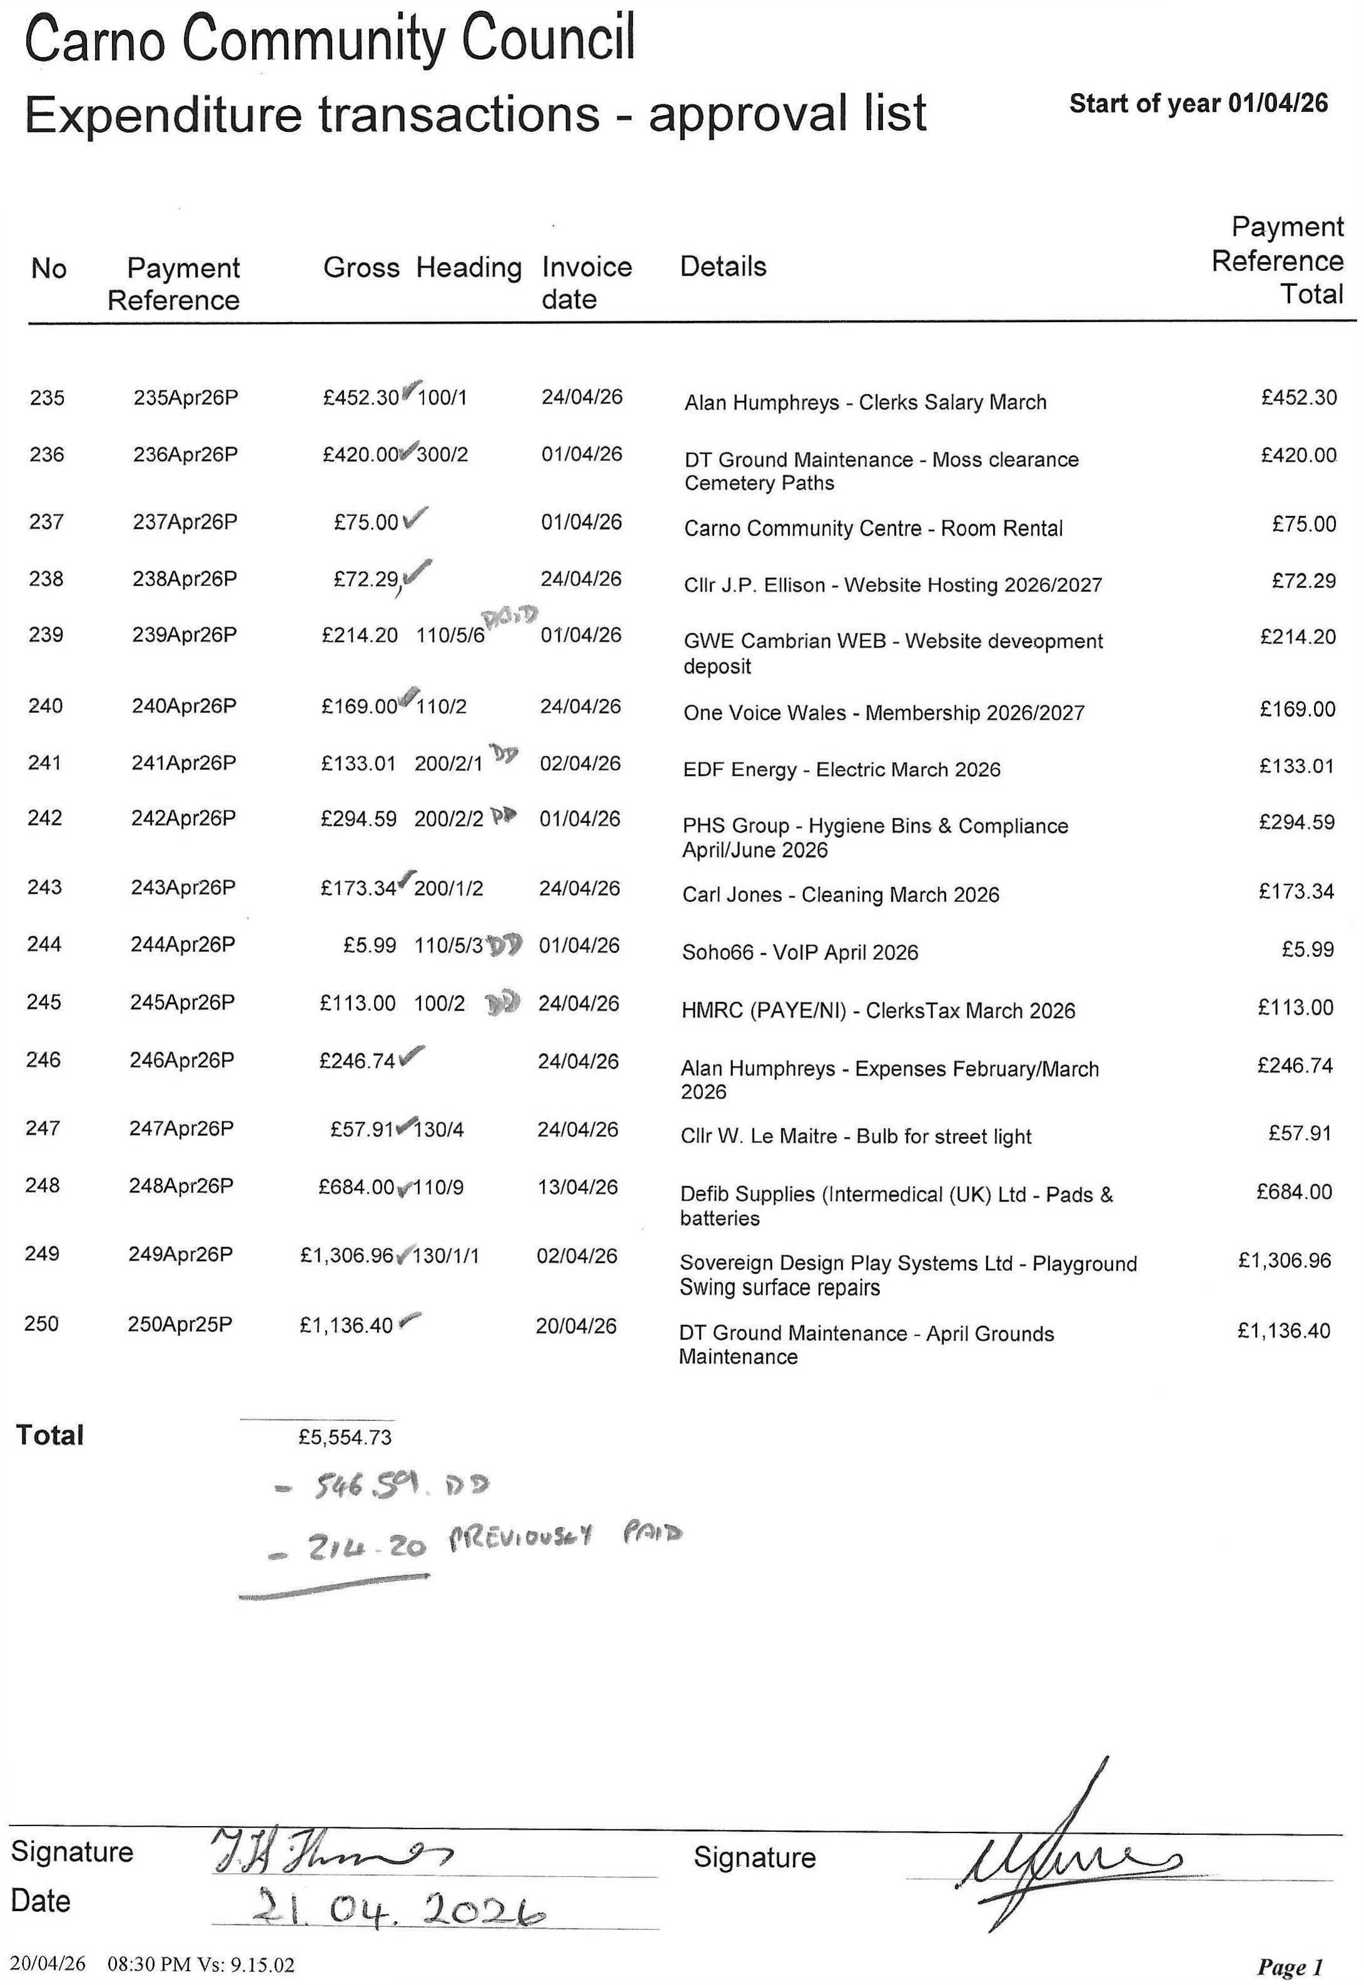

April 2026 Payment Approval list.

