Minutes of Cyngor Cymuned Carno Community Council held on
Tuesday 15 April 2025
at 7.30pm in the Cledan Room, Canolfan Gymdeithasol Carno Community Centre.

- Present.
 | Cllrs. | J.C. Barnes (Chairperson), J.P. Ellison, S.L. Jerman, D.I. Jones, M.H. Jones & T.H. Thomas.
 | Cllr. | Les George.
 |  | Alan Humphreys (Clerk to the Council & RFO.).

- Apologises for Absence.
 | Cllrs. | S.R. Kiely (Vice-Chairperson) & W Le Maître.

- Declaration of Interest.
None.

- Approval of the Minutes of the Previous Meeting.
The Minutes of the meeting of Cyngor Cymuned Carno Community Council held in the Cledan Room, Canolfan Gymdeithasol Carno Community Centre on
Tuesday 18th February & 18th March 2025 were unanimously agreed
 | Proposed Cllr: | D.I. Jones | Seconded Cllr: | T.H. Thomas.
 | It was noted that the April Agenda included items from the March 2025 Meeting which did not take place due to a lack of a quorum.

- Cemetery.
  - Cemetery Inspection Rota.
Inspection to be done by March 2025. | Cllr. T.H. Thomas. | Cllr. D.I. Jones.
Cllrs. T.H Thomas & D.I. Jones had inspected the Cemetery and found no issues to report.
Inspection to be done by June 2025. | Cllr. S.L. Jerman. | Cllr. W, Le Maître
Inspection to be done by September 2025. | Cllr. J.C. Barnes. | Cllr. J.P. Ellison.
  - Fencing. No progress.

- Matters Arising.
  - Matters Reported to Powys County Council.
Location. | Issue. | Powys Ref. | Comments.
Trem y Noddfa Carpark.  SY17 5LJ. | Potholes. | JD171795 | Powys CC Housing are responsible.  16.08.2022. Cllr Les George reported he had chased the matter again.  20.06.2023. Scheduled with Powys CC Housing Budget. Cllr George chasing.  16.01.2024. Update received. Powys Housing talking to Contractors.  01.03.2024. Work scheduled for April 2024.  28.05.2024. Waiting on Contractor.  01.09.2024. Powys waiting Contractor schedule.  13.01.2025. Powys unable to find a contractor.
Trem y Noddfa Carpark.  SY17 5LJ. | Blocked Drain. | JD188470
Frankwell.  SY17 5LP. | Overgrown. Flooding issue | 6178-0656-5808-6548. | 25.10.2022. Under investigation  28.10.2022. Passed to Powys CC Land Drainage Section.  18.07.2023. Unable to establish ownership of trees.
Cerniog Bridge  SY17 5LS | Lack of road markings | 0088-0514-9178-8732 | 26.07.2024. Reported  02.08.2024. Added to Works list
Lane to Waun. SY17 5LS | Overgrown verges | 4373-0952-5186-5035 | 26.07.2024. Reported.  02.08.2034. Already reported
Tan y Derw  Stone House. SY17 5LS | Flooding & blocked culverts, | 0229-9626-0287-1126 | 07.01.2025. Reported.
Glan Hanog Lane. SY17 5JU. | No salt piles | 0505-7869-9938-5703 | 01.02.2025. Reported.  13.02.2025. Advised request has been logged. Job raised.  20.02.2025. Completed.
Rhyd Bank.  SY17 5JY. | No salt piles | 0505-7869-9938-5703
1-4 Maes y Dafarn. SY17 5NG. | Over hanging tress blocking footpath, | 5552 4364 4645 0228 | 01.02.2025. Reported.
  - Matters Reported to the MNWTRA.
Location. | Issue. | TRA Ref. | Comments.
Ty Brith/Aleppo | Overgrown trees. | W24125369 | 17.07.2024 Reported.  01.09.2024, No action proposed as the trees are not mature enough.
Ty Mawr Farmyard | No drop kerbs | W24126165. | 02.09.2024. Reported,  22.11.20204 To be actioned 2025 Financial Year.
Sarn Bridge. | Overgrown trees. | W24126819 | 07.10.2024. Reported.
Layby A470 Sarn. | Litter | W25130802 | 31.03.205. Reported.  02.04.2025. Referred to Powys CC.
  - Ward Councillors Report. (Cllr. Les George).
    - Cllr George had little to report that was not covered elsewhere.
  - Carno Station Action Group. (Cllr. J.C. Barnes).
    - Cllr. Barnes reported that a Coffee Morning to update people and hopefully attract further members would take place on 26.04.2025. The event would be attended by our MP. Steve Witherden.
  - Public Convenience.
    - The issues with the ‘Ladies’ have yet to be resolved.
      - After a discussion it was agreed that the issues at the Convenience needed urgent action as the Council was losing income through the door locks not working.
  - Defibrillator.
    - The electrical connection had been installed and the Defibrillator and Cabinet delivered. It was now a case of getting an electrician to install it.
  - Pedestrian Crossings,
    - No progress.
  - Fallen Fence, Gerddi Cledan.
    - The Clerk would had yet to contact to the owners of the land.

  - Audio Conferencing. (Cllr J.P. Ellison)
    - Cllr Ellison advised the Meeting that the system had been tested with up to 4 users and should now been deemed ‘live’
    - Procedures had yet to be agreed and publicised.

- Planning.
For further details access the Powys CC Planning Portal.
(https://pa.powys.gov.uk/online-applications/?lang=EN).
  - Planning Applications.
  - Planning Applications.
Application No. |  |  | Location | Description
 |  |  | None.
  - Planning Approvals.
Application No. |  |  | Location | Description
 |  |  | None.
  - Planning Refusals.
Application No. |  |  | Location | Description
 |  |  | None.
  - Planning Applications Awaiting a Powys CC. Decision.
Application No. |  |  | Location | Description | Council’s Response
 |  |  | Esgair Cwmowen Windfarm. | Additional information. | No Objection.
  - Illegal Dwelling, Glanhanog & Opposite.
  - Planning Decision Lists.
20th January to 21st February 2025. | None in Carno.
24th February to 14th March 2025. | 1 in Carno.
17th March to 28th March 2025 | None in Carno.
  - Planning Breaches at Glanhanog, Opposite & Glanrhyd.
    - Powys CC had failed to investigate the matters and Cllr Les George expressed his frustration with the Planning Department lack of response to his enquires.
    - A possible further breach of planning had been reported to the Council at Glanrhyd.

- Correspondence.
  - Abbreviations.
CAB. | Citizens Advice Bureau.
CEIC. | Circular Economy Innovation Communities
CMI. | Cambrian Mountains Initiative.
CSAG. | Carno Station Action Group.
DP Police Commissioner. | Dyfed/Powys Police Commissioner.
DPNW. | Dyfed-Powys Neighbourhood Watch
EASC. | Emergency Ambulance Service Committee.
IRP Wales. | Independent Remuneration Panel for Wales.
MWWFRS. | Mid & West Wales Fire & Rescue Service.
NMWTRA. | North & Mid Wales Trunk Road Authority.
NRW. | National Resources Wales.
OLPW. | Older Peoples’ Commissioner Wales.
ONS. | Office for National Statistics.
OP Commissioner. | Older Peoples Commissioner.
OVW. | One Voice Wales.
PAVO. | Powys Association of Voluntary Groups.
PACE. | Powys Action on Climate Emergency.
PAW. | Planning Aid Wales.
PCC. | Powys County Council.
Powys CHC. | Powys Community Health Council.
Powys PSB. | Powys Public Service Board.
Powys RPB. | Powys Regional Partnership Board.
Powys THB. | Powys Teaching Health Board.
PSO Wales. | Public Service Ombudsman for Wales.
RNID. | Royal National Institute for the Deaf.
SPEN. | Scottish Power Energy Networks.
TfW. | Transport for Wales.
WG | Welsh Government.
Welsh TRA. | Welsh Government Trunk Road Authority.
WISERD. | Wales Institute of Social & Economic Research & Data.
WLGA. | Welsh Local Government Association.
OVW. | Digital Guidance.
  - Received by Post.
MARCH 2025
Clerk & Councils Direct. | Newsletter.
Carno Bowls Club, | Letter of thanks for grant.
APRIL 2025
None.
  - Received via Email.
(Emails listed were received since the last meeting and forwarded to Councillors for their consideration).
MARCH 2025
Parishes Online. | Newsletter 56.
Bute Energy. | Llyn Lort Energy Park Community Council 'Clinic'. 26.02.2025.
DP Police Crime Commissioner. | Police and Crime Plan 2025 – 2029.
OVW. | Digital Guidance
Powys CC. | 20mph review.
OVW. | Online Events from the Cost-of-Living Crisis.
Wind 2 Quarto PR. | New proposals for Parc Ynni Calon y Gwynt - Wind2.
TfW. | Cambrian Rail. Buses Replace Trains. 17th March to 2nd April
SPEN. | SPEN Stakeholder Engagement.
OVW. | Postponing the Annual General Meeting.
OVW. | Upcoming Online Events. The Cost-of-Living Crisis Team.
PAVO. | Training / Hyfforddiant.
PCC. | Community Wellbeing Events – Spread the Word.
WG. | Role, Governance & Accountability of Community & Town Council Sector
PAVO. | Minutes of Llanidloes Locality Network Meeting.
WG. | Diversity and inclusion guidance for registered political parties.
OVW. | Child Poverty Innovation and Supporting Communities grant fund
WG. | Senedd Review Final Determinations.
OVW. | Training Dates - March - June 2025
Powys CC. | Household Recycling Centre changes: the facts.
Powys CC. | Open Space Questions.
OVW. | Online Events from the Cost-of-Living Crisis Support Team.
OVW. | Child Poverty Innovation and Supporting Communities grant fund.
OVW. | One Voice Wales and Planning Aid Wales Joint Event 27 March.
Llais. | March Newsletter 2025.
OVW. | Webinar – Section 6 Reports 2025.
Tesco. | Tesco Stronger Starts - North/Mid Wales.
APRIL 2025
British Heart Foundation. | The Circuit Newsletter.
Parish Online. | Newsletter 57.
Machynlleth TC. | Future of the Plas Leisure Centre.
OVW. | Launch of the New One Voice Wales Website.
Ponthafren. | Powys-Wide Informal Volunteering Project.
OVW. | REMINDER Area Committee Survey
PAVO. | PAVO E-bulletin - March 2025.
MWWFRS. | Calon Tân Magazine: Spring 2025.
OVW. | What are your views on the Active Travel Act Guidance?
OVW. | Wales’s Regional Transport Plans.
OVW. | 𝐒𝐞𝐜𝐭𝐢𝐨𝐧 𝟔 𝐑𝐞𝐩𝐨𝐫𝐭𝐬 𝟐𝟎𝟐𝟓 - 𝐒𝐞𝐬𝐢𝐰𝐧 𝐍𝐞𝐰𝐲𝐝𝐝 / 𝐍𝐞𝐰 𝐄𝐯𝐞𝐧𝐢𝐧𝐠 𝐒𝐞𝐬𝐬𝐢𝐨𝐧
TfW. | Newtown Station Accessibility Update: Lifts Now Open.
Dyfi Biosphere. | Newyddion y Biosffer - Biosphere News.
HM Government. | Reimagine Public Sector conference series has officially launched.
MWWFRS. | Chief Fire Officer Commends Response to Grass Fires.
OVW. | 𝐒𝐞𝐚𝐥𝐬: 𝐖𝐚𝐥𝐞𝐬’ 𝐆𝐢𝐚𝐧𝐭 𝐩𝐚𝐧𝐝𝐚!.
MWWFRS. | Wildfire Wise.
St John Ambulance. | People First - March 2025.
Powys CC. | Sustainable Powys - Let’s Talk!
Network Rail | Update on the Cambrian line.
Network Rail | Update on the Cambrian line.
PAVO. | Llanidloes Locality Network Meeting.
Russell George MS. | April Newsletter
OVW. | Montgomery Area Committee 8.4.25.
OVW. | Upcoming Online Events from the Cost-of-Living Crisis Support Team.
OVW. | Motions for 2025 Annual General Meeting.
WG. | Welsh Government Democratic Engagement Grant.
Llais. | April Newsletter.
OVW. | Compassionate Communities in Wales event – Thursday 8 May 20.
OVW. | Ystadau Cymru Asbestos Awareness Training.
Green Gen Cymru. | Vyrnwy Frankton statutory consultation closing this week.

- Finance.
  - Expenditure & Income.
    - Reconciliations approval to 28.02.2025 & 31.03.2025
    - The March 2025 & April 2025 Expenditure and Income lists at the end of these Minutes were unanimously approved .
Proposed Cllr: | T.H. Thomas. | Seconded Cllr: | D.I. Jones.
    - Financial Summary following approval of the Income & Expenditure.
Account | Balance | Approval at |  |  |  | Projected Balance
Account | Balance | March 2025 Meeting |  |  |  | Projected Balance
Account | 01.03.2025 | Expenditure Bankline | Expenditure Other | Total Expenditure Finance Authorisation Sheet | Income Finance Authorisation Sheet | 31.03.2025
Precept | £12,612.96 | £4,247.44 | £228.84 | £4,476.28 | £0.00 | £8,136.68
Cemetery | £0.00 | £0.00 | £0.00 | £0.00 | £0.00 | £0.00
Interest | £15,313.81 | £0.00 | £0.00 | £0.00 | £0.00 | £15,313.81
Totals | £27,926.77 | £4,247.44 | £228.84 | £4,476.28 | £0.00 | £23,450.49

    - Account Summary of Income & Expenditure - April 2025.
Account | Balance | Approval at |  |  |  | Projected Balance
Account | Balance | April 2025 Meeting |  |  |  | Projected Balance
Account | 01.04.2025 | Expenditure Bankline | Expenditure Other | Total Expenditure Finance Authorisation Sheet | Income Finance Authorisation Sheet | 30.04.2025
Precept | £6,850.69 | £1,984.03 | £504.10 | £2,488.13 | £8,957.51 | £13,320.07
Interest | £15,313.81 | £0.00 | £0.00 | £0.00 | £16.26 | £15,330.07
Totals | £22,164.50 | £1,984.03 | £504.10 | £2,488.13 | £8,973.77 | £28,650.14

    - Financial Reports for End of Year 2024/2025.
      - The Clerk reported that the 2024/2025 Financial Year had been closed off. The carry was in line with that he had outlined in the Precept 2025/2026 document.
      - The 2024/2025 documentation had been received with the accounts going to the Internal Auditor by the end of April.
    - Appeals for Funding.
      - Marie Curie Great Daffodil Appeal 2025.
      - Llangollen International Musical Eisteddfod.
      - It was not possible to contribute to these two requests.

- Matters for Discussion.
  - Matters raised by Councillors.
    - Cllr. D.I. Jones asked for repair to potholes from the Rhyd to Y Cwm to be repaired.
    - Cllr J.C. Barnes asked for applicable road signage to be installed on the A470 to advise motorists of the Glanhanog turning. With the number of dwelling now standing at 7, there was increased traffic movements in/out of the junction. There was a particular problem when turning right of the A470 a following traffic was unaware that cars had stopped to turn right. The same issues were identified for the turning for Tan y Llyn Cottages. The Clerk would contact the Trunk Road Authority.
  - Date of the Next Meeting.
Tuesday 27th May 2025
Due to numerous Councillors being unavailable on the normal date for a Meeting, (20.05.2025), it was agreed to move the May Meeting back a week.
The Clerks informed the Meeting that the May 2025 Meeting would also be the date for the 2025 Annual General Meeting.

The Chairperson closed the Meeting at | 8.45pm

Signed as a true and accurate record of the meeting of
Cyngor Cymuned Carno Community Council held in the Cledan Room,
Canolfan Gymdeithasol Carno Community Centre at 7.30pm on
Tuesday 15th April 2025.
Signed | Alan Humphreys
Alan Humphreys
Clerk to Cyngor Cymuned Carno Community Council
Signed: |  | Date: | 27th May 2025
Cllr. J.C. Barnes
Chairperson, Cyngor Cymuned Carno Community Council

Carno Community Council
Expenditure transactions - payments approval list – March 2025.
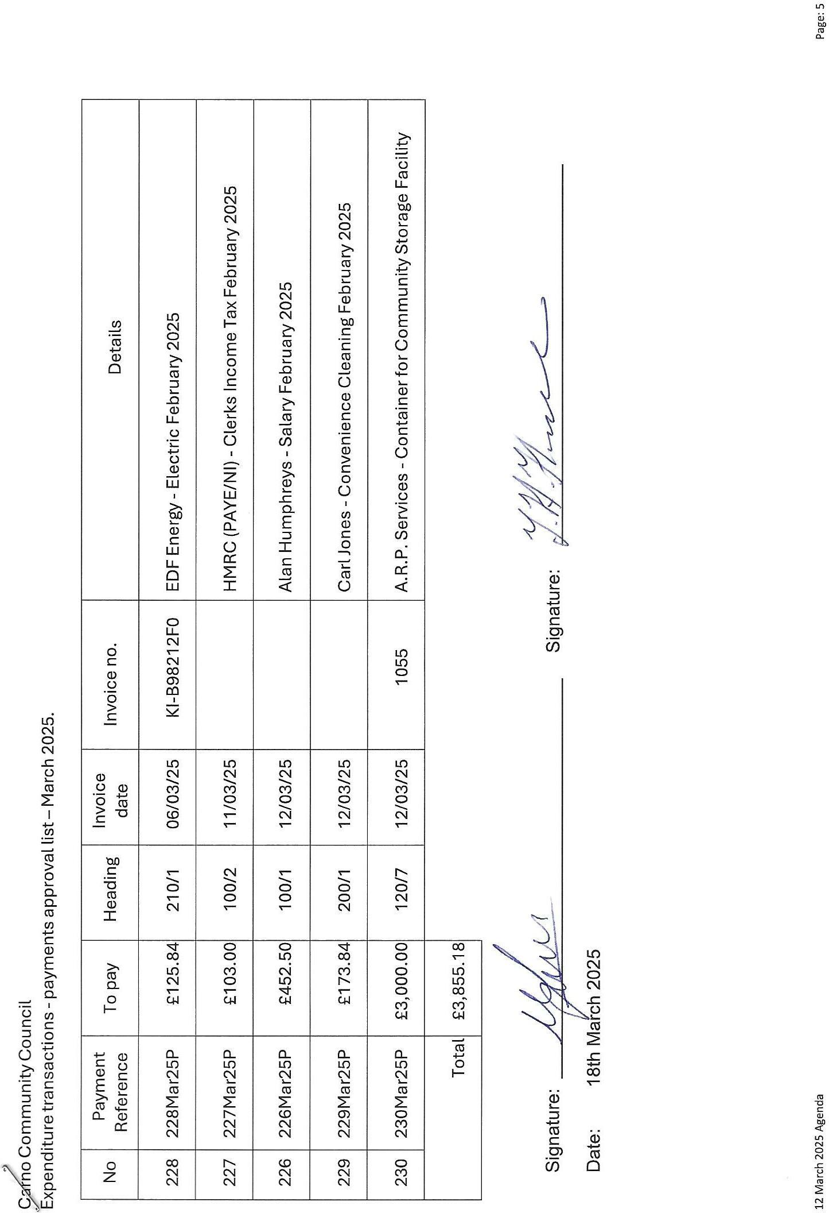

Carno Community Council
Expenditure transactions - payments approval list – April 2025.


